Virtual Project Manager User Guide:
Training Videos and Forms
This User Guide is to be used in accordance with the Contract Documents, Supplementary Special Provisions to the 2018 Edition Whitebook, Section 5-13 (or 2015 Edition Whitebook, Section 7-20), "ELECTRONIC COMMUNICATION".

The contractor shall electronically submit the following items utilizing VPM:
- Transmittals
- Submittals
- RFIs
- Monthly Progress Payment

Virtual Project Manager Training Videos
Welcome to the Virtual Project Manager training videos support page. The videos are designed to be brief and show you how to perform a particular activity.
#1 - Virtual Project Manager Overview (Video Hyperlink)
#2 - Virtual Project Manager Request Form (Video Hyperlink)
#3 - Virtual Project Manager User Login (Video Hyperlink)
#4 - Virtual Project Manager Project Administration Part 1 (Video Hyperlink) #5 - Virtual Project Manager Project Administration Part 2 (Video Hyperlink) #6 - Virtual Project Manager Daily Logs (Video Hyperlink)
#7 - Virtual Project Manager Submittals Transmittals and RFIs (Video Hyperlink)

Virtual Project Manager Forms
Virtual Project Manager Request Form - This form needs to be provided to the IT department by the RE. See below attached on page 2.

Sensitive Information Authorization Acknowledgement Form - City Contractors, Vendors, and Consultants need to provide this form to the RE at Pre-Construction Meeting. See below attached on page 3.

Virtual Project Manager User Agreement - City Contractors need to provide this form to the RE at Pre- Construction Meeting. See below attached on page 4.

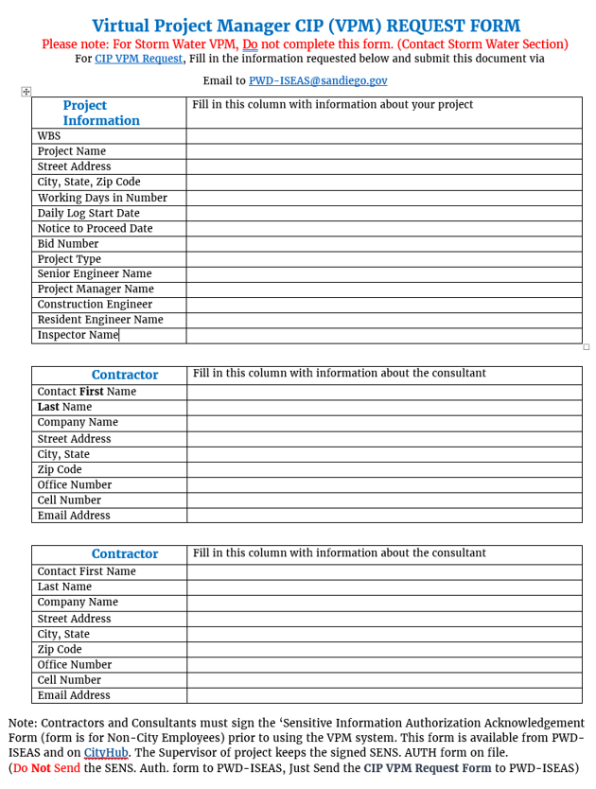
CITY OF SAN DIEGO
Sensitive Information Authorization Acknowledgement Form – City Contractors/Vendors Authorized Person (City Contractor/Vendor requesting authorized access to Sensitive Information):
Name (Printed) | eMail Address | Network (AD) Login/User ID
Company/Organization |  | Contractor/Vendor Office Phone
City Department (managing contract) |  | Contractor/Vendor Office FAX
City Contract Manager’s Name (Printed) | City Contract Manager’s Phone | City Contract Manager’s Mail Sta.

Policy Summary (pertinent excerpts from City Administrative Regulation 90.64):
4.1 Sensitive Information shall be maintained in a confidential manner and access restricted to only employees or individuals properly authorized by his or her Appointing Authority and approved by the Information/Data Owner, based on verified business needs to have access to such information and/or in compliance with specific legal requirements.
4.3 Authorization to access or use Sensitive Information shall be based on a functional role (job duties) and not linked directly with a specific individual, such that when an authorized person’s job duties no longer require access to or use of Sensitive Information, the ability to access or use such information shall be revoked. At no time shall a contractor’s or vendor’s access to Sensitive Information extend beyond the termination of the authorizing contract, and such access shall be revoked as soon as the duties requiring access or use have ended, regardless of the end date of the contract.
4.5 Authorized Persons shall access or use Sensitive Information only for its intended purpose for which it was obtained and maintained by the City of San Diego. An employee or individual authorized to access or use Sensitive Information shall sign an Authorization Acknowledgement Form stating he or she has read, understands, and agrees to abide by this policy.
4.7 Violation of this policy, either by unauthorized persons accessing or attempting to access Sensitive Information, or by Authorized Persons accessing or using Sensitive Information for other than its intended purpose or beyond the scope of their duties, may result in disciplinary action, up to and including termination of employment, and also subject the violating individual(s) to personal liability without the option of City legal defense. In the case of contractors or vendors, violation of this policy will be considered a breach of contract and appropriate actions taken on that basis. If deemed necessary, information regarding employee, volunteer, contractor or vendor violation of this policy may be referred to the appropriate agency for any civil and/or criminal action, as applicable.

Acknowledgement

By signing below, the above City Contractor/Vendor (“Authorized Person”) acknowledges the he or she understands that the Terms and Conditions of the underlying City Contract contain the provisions of the full policy stated above, and he or she agrees to comply with such contract provisions. City Contractor/Vendor understands that this form will be kept on file with the underlying contract documents in the City Purchasing & Contracting Department, and that he or she may receive a copy, if requested. The City Contract Manager acknowledges that he or she has discussed the contract Terms and Conditions related to this policy with the above Contractor/Vendor (Authorized Person) and understands the supervisor’s obligations regarding the Contractor’s/Vendor’s access to the City’s Sensitive Information under this policy.

Authorized Person’s Signature (Contractor/Vendor) Date Signed

City Contract Manager’s Signature Date Signed

Form IT-010C (Rev. 02/2010) (City Contractor/Vendor Form)

Terms Of Virtual Project Manager Use

Project Name:
WBS:
Resident Engineer:
Contractor:

When specified in the Supplementary Special Provisions, the Contractor shall post all communications addressed to the Engineer concerning construction including: RFIs, submittals, daily logs, and transmittals to the Virtual Project Manager (VPM) website established for the Project; maintain a list of scheduled activities including planned and actual execution dates for all major construction activities and milestones defined in the approved Schedule; and review and act on all communications addressed to you in the VPM project website. A user’s guide for the VPM system is available on the City’s website and shall be provided to you at the Pre-construction Meeting.

The Resident Engineer (RE) agrees to be responsible for the input of all fields in the “Project Info” section of Virtual Project Manager (VPM) and ensure that the “Working Days In Contract” and the “Notice To Proceed Date” are correct so that the Weekly Statement Of Working Days (WSWD) can be accurately calculated. Additionally, the RE agrees to setup a storm water project in VPM and do all storm water reporting/communications using the storm water module of VPM. The contractor shall be responsible for providing name and email address of person or persons to receive BMP Notices. If any changes are made, the RE shall be notified.

Both parties agree to participate fully in the discussion of RFIs and Submittals in VPM until resolution.

Failure by the Contractor to utilize VPM as required by this agreement will delay the City response time, and result in unrecoverable lost time affecting the allowed working days of the contract. Exceeding the total working days of the contract may be cause for liquidated damages as stated in the contract provisions, section 6-9.

By signing below I agree to the terms of this agreement.

Resident Engineer: Date:

Contractor: Date:

