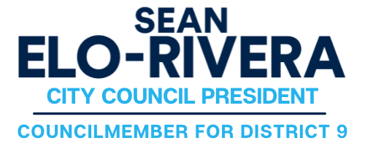

FOR IMMEDIATE RELEASE CONTACT: Chris Chan
January 11, 2023 Phone: 619-221-3288

Council President Elo-Rivera’s Response
to Mayor Gloria’s State of the City Address

San Diego – Below please find a statement from San Diego City Council President Sean Elo-Rivera on Mayor Todd Gloria’s State of the City Address.

I want to thank Mayor Gloria for his leadership in addressing the most important issues facing our city, in particular increased funding to prevent people from falling into homelessness and incentivizing the production of more affordable housing. I look forward to working with Mayor and my colleagues on the City Council to improve the lives of the residents of San Diego.

----
Council President Elo-Rivera represents San Diego’s Ninth Council District including communities of City Heights, College Area, El Cerrito, Kensington, Mission Valley East, Mountain View, Mt. Hope, Normal Heights, Rolando Village, Rolando Park, Stockton and Talmadge. He is the Chair of the Rules Committee and serving his second term as San Diego City Council President.

###

