Mid-City Communities Plan Update
Working Group Meeting Summary

MEETING DETAILS
March 19, 2025 • 6:00 – 8:00 P.M.
Normal Heights Community Center
4649 Hawley Boulevard San Diego, CA 92116

The meeting was conducted in a hybrid format, allowing participation in-person and via Zoom.

PURPOSE AND OVERVIEW
During the first part of the Working Group meeting, the City presented the Public Engagement Summary and Draft Historic Context Statement and Survey. The Working Group members shared their comments and provided feedback after each presentation. In addition, a portion of the meeting was dedicated for public comment. Community members discussed the aspects of the presentation that stood out to them and suggested ideas and provided feedback.
BACKGROUND
As a part of an inclusive engagement process, the City has convened a Working Group for the Mid-City Communities Plan Update. The primary role of the Working Group is to inform the Mid-City Communities Plan Update process. Additional details can be found by reviewing the Mid-City Communities Plan Update Working Group Protocol and Membership (April 16, 2024). In addition, an orientation was held for Working Group members on April 24, 2024, to encourage members to make connections with other members and inform the Working Group on what to expect of their role and timeline of their involvement.
The City published the Draft Mid-City Atlas online on June 14, 2024. The first Working Group meeting on June 26, 2024 included a presentation and discussion of the "Introduction," "History and Place," and "Sustainability, Climate, Equity, and Resilience" chapters of the Draft Mid-City Atlas. The City released a Draft Overview of Key Community Engagement Efforts on September 4, 2024. The Draft Overview of Key Community Engagement Efforts includes key engagement efforts such as online surveys, in-person workshops, pop-up events, office hours, community interviews, emails, and youth engagement. Additionally, it features appendices with detailed information from the workshops, including attendance records, comments from community members, poll results, Zoom chat transcripts, and discussion group notes.
The second and third Working Group Meetings were held on September 11th and December 11th, 2024, respectively. The September session focused on presentations and discussions of key highlights from the "Land Use & Development," "Mobility," and "Parks, Public Facilities & Open Space" chapters of the Draft Mid-City Atlas. In the December meeting, the City presented the Draft Existing Conditions Mobility Assessment and an overview of Historic Preservation.
WORKING GROUP MEETING PARTICIPANTS
A total of 14 Working Group members attended the meeting as shown in Table 1. Eleven Working Group members attended in person, three attended virtually, and two were absent.
Table 1 - List of Working Group Attendees
Working Group | Attendance | Community
Steve Aldana | In-Person | City Heights
Marcellus Anderson | Virtually/Zoom | Designee - City Heights CPG
Thomas Aristide | In-Person | Normal Heights
Madeleine Baudoin | Absent | Normal Heights
Emilie Colwell | In-Person | Designee – Normal Heights CPG
Lynn Edwards | Virtually/Zoom | Designee - Eastern Area CPG
Brittany Gordon | Absent | City Heights
Eric Kelley | In-Person | Eastern Area
David Moty | In-Person | Designee - Kensington-Talmadge CPG
Nam Nguyen | In-Person | City Heights
Victor Ponce | In-Person | City Heights
Paul Smith | In-Person | Eastern Area
Kristen Spittle | In-Person | Kensington-Talmadge
Lisa Stone | In-Person | Kensington-Talmadge
Randy Torres-Van Vleck | In-Person | City Heights
Zach Young | Virtually/Zoom | Eastern Area
PUBLIC ATTENDANCE
In addition to the Working Group members, there were 34 members of the public that attended the meeting. Ten members of the public attended in-person, and 24 attended virtually.
STAFF ATTENDANCE
The Working Group meeting was supported by City staff listed in Table 2.
Table 2 – Staff Attendance
Project Team | Attendance | Affiliation
Alexander Frost | In-Person | City of San Diego
Shannon Corr | Virtually/Zoom | City of San Diego
Morgen Ruby | In-Person | City of San Diego
Aparna Padmakumar | In-Person | City of San Diego
Selena Sanchez Bailon | In-Person | City of San Diego
Kelly Stanco | Virtually/Zoom | City of San Diego
Bernard Turgeon | In-Person | City of San Diego
Kelsey Kaline | In-Person | City of San Diego
Mauricio Aguilar | In-Person | City of San Diego
Coby Tomlins | Virtually/Zoom | City of San Diego

MEETING SUMMARY AND ACTIVITIES
At the beginning of the meeting, staff welcomed Working Group members and the public to the meeting. Given it was a hybrid meeting, the Working Group members who attended online were encouraged to have their cameras switched on and “rename” Zoom to include their name and which community they represented. The meeting started with an introduction, meeting logistics and agreement, followed by presentations on the Public Engagement Summary. Working Group members then shared their feedback through a facilitated discussion, zoom chat feature, or on comment cards. The questions used to prompt discussion included:
- Are there any surprises?
- Is there something missing?
- Any themes you want to emphasize or elevate?
The meeting continued with the City giving a presentation focused on the findings from the Draft Historic Context Statement and Survey, which will inform the Historic Preservation component of the Mid-City Communities Plan Update. After presenting these findings, the Working Group members provided their feedback based on the following questions:
- Any clarifications or questions?
- Any sites that should be added to the study list?
- What’s important in social and cultural history of the Mi-City communities that we should be aware of?
- Are there any general comments?
Notes from the Working Group’s discussion related to the Working Group Meeting are included in Appendix A.
The meeting concluded with City staff outlining upcoming events and engagement opportunities.
Records of the questions and answers during the public comment portion of the meeting are included in Appendix B; comments from the Zoom chat are compiled in Appendix C.
NEXT STEPS
- The next Working Group meeting is scheduled for August 2025
- Outputs from the engagement process and existing conditions, along with the technical studies, will contribute to the development of the draft concepts, which are expected to be released later this year
- Extensive community engagement will take place through open houses in the four communities related to the Ideas Report, likely starting in the late summer
- Public comment period was open for the Draft Historic Context Statement & Survey until May 31, 2025
- A Draft Framework Vision & Concepts is planned to be released in Summer 2025

APPENDIX A – WORKING GROUP DISCUSSION NOTES
Feedback provided from Working Group members in response to Public Engagement Summary and Draft Historic Context Statement and Survey Report included the following:

PUBLIC ENGAGEMENT SUMMARY
- Emphasis on the importance of keeping canyons clean for public safety reasons.
- A concern was raised about the wildfire in Montezuma that occurred on October 31, 2024, which damaged nearby properties.
- A suggestion was made to find a balance between preserving natural canyon environments and conducting necessary brush clearing, as determined by the fire department.
- A request was made to include visual examples or conceptual illustrations to accompany planning ideas, rather than presenting them in abstract terms.
  - Staff’s answer: At the next Working Group meeting, a presentation on the Ideas Report will be provided. This presentation will include visual representations of land use alternatives, urban design concepts, focused study areas, park and recreation ideas, and mobility concepts. The Ideas Report will be developed based on the existing conditions report (Mid-City Atlas) and all feedback received to date.
- A comment was made that having visual materials would help the public better understand what is being asked of them in surveys, particularly regarding parks, open spaces, and neighborhoods.
- An inquiry was made about requesting neighborhood boundary adjustments involving the Eastern Area, College Area, and El Cerrito/Rolando neighborhoods, similar to the boundary line adjustment between Kensington-Talmadge and the College Area, which was mentioned at a Planning Commission meeting
  - Staff’s answer: A letter requesting a boundary line adjustment between the College Area and Kensington-Talmadge community planning groups (CPGs) was submitted last year and is currently under consideration. We recommend that the Eastern Area CPG, along with adjacent community groups, submit a formal letter outlining their specific boundary adjustment request to initiate a similar process.
- It was noted that the summary of community feedback presented was consistent with feedback gathered from previous outreach events and data collection.

DRAFT HISTORIC CONTEXT STATEMENT AND SURVEY REPORT
- A suggestion was made to add Thien Hau Temple at 4538 University Avenue to the study list (referenced on p. 68), noting its cultural and religious importance to the Vietnamese community and its frequent use for events like the Lunar New Year festival.
- A recommendation was made to study a small area in the southwestern corner of Normal Heights. This area may be a candidate for a historic district because it was not impacted by the Huffman Six Pack development pattern due to the absence of alleys.
- It was noted that on certain slides, the boundary of the Talmadge Gates Historic District appears to be slightly inaccurate and may need correction.
- One slide stated that the list of potential historic resources sites is not open to public comment. A clarification was requested on whether this is accurate or if the comment period is still open.
  - Staff’s answer: Public comments on the Draft Historic Context Statement and Survey Report were accepted until May 31st.
- A question was raised about whether mixed-use development areas were considered in the study.
  - Staff’s answer: Mixed-use development areas were included in the reconnaissance-level survey. However, no potential historic districts were identified within those areas. Despite this, properties in mixed-use development areas remain subject to individual historic review as part of the City’s ongoing processes.
- A request was made for clarification on whether mixed-use areas can still be considered under Tier 3 or 4 criteria, or if that is yet to be determined.
  - Staff’s answer: Mixed-use development areas were not included in the tiering framework of the study. That said, we welcome community input. The goal is to identify shared histories and potential historic districts. If community members believe there are cohesive clusters of buildings in mixed-use development areas that may qualify as historic districts, we encourage those suggestions.
The reconnaissance survey broadly assessed two primary criteria: (1) potential historic districts and (2) master-planned communities—areas with uniform development characteristics such as architecture, time period, and builder. Mixed-use areas typically lacked this cohesion, making them more difficult to evaluate under the same framework. However, properties within these areas will continue to be assessed individually under the City’s 45-year review process, and the study list will inform the identification of potential historic resources in mixed-use development areas.
- A question was asked about how the significant immigration window of 1975 to 1990 was determined.
  - Staff’s answer: The 1975–1990 period was defined based on research conducted by the consultants and is discussed in detail in the historic context statement. The year 1975 marks the beginning of significant Vietnamese immigration to City Heights. The year 1990 is used as a general guideline, reflecting the challenges of evaluating more recent history within a preservation framework.
This timeframe does not suggest that immigration stopped in 1990. Rather, it marks a point beyond which it becomes more difficult to assess historical significance due to a lack of temporal perspective. We acknowledge that immigration and community diversification continued beyond this period.
It’s important to note that both the context statement and survey are living documents. As time passes, these can and should be updated to reflect emerging historical themes and resources, including those related to more recent immigration waves.
- A recommendation was made to include the Somali community in the historical analysis, noting City Heights’ significant Somali population, which began arriving in the mid-1990s following the Somali Civil War.
- A request was made to explain the difference between a historic district and a cultural district.
  - Staff’s answer: Cultural districts are not part of the City’s historic preservation program. They are not designated historic resources and are not identified by the City’s Historical Resources Board. Cultural districts are established by the City Council and are focused on a sense of place, economic vitality, and cultural recognition. They do not involve any historic preservation-related processes or regulations.
Historic districts are different. They require an intensive-level survey and evaluation to determine historic significance. This involves evaluating properties individually and within a defined geographic area. Historic districts vary in scale but must meet the City’s historic designation criteria. The decision to designate a historic district is made by the Historical Resources Board and can be appealed to the City Council.
- A question was asked about the significance of historic districts from a planning and development perspective.
  - Staff’s answer: Historic districts have regulations associated with them and may qualify for certain benefits available through the City’s historic preservation program. However, designation as a historic district does not prohibit new development. Housing and adaptive reuse can be allowed within historic districts, as long as the work follows historic standards and regulations. These projects can typically proceed through the building permit process. A Site Development Permit is only required if the proposed work does not comply with applicable historic standards.
- Two additional potential historic resources were recommended:
  - A group of four houses at the intersection of 58th Street and Adelaide Avenue in El Cerrito, including one original farmhouse that predates surrounding development.
  - City Farmers Nursery, established in 1972 in City Heights, which was described as a unique and meaningful local property.
- A concern was raised about the potential misuse of historic districts to block necessary development. The commenter expressed skepticism about how historic designations can be used by affluent, politically connected residents to prevent housing, especially during a time of rising housing costs.
- A related concern was shared regarding tax breaks associated with historic designations, especially when they benefit multimillion-dollar properties. The commenter expressed discomfort with such benefits amid city budget deficits.
- A recommendation was made to recognize the role of public transportation in San Diego’s growth, highlighting the city's early investment in transit infrastructure and its influence on neighborhood development.
- It was observed that the Eastern Area primarily contains Tier 2 and Tier 3 housing, suggesting limited historic significance overall.
- Appreciation was expressed for the inclusion of two specific assets from the Eastern Area in the Historic Context Statement: College Grove shopping center and the Chollas Heights Naval Radio Transmitting Facility.
- A commenter disagreed with the notion that historic districts hinder housing and growth, using Manhattan as an example where both density and preservation coexist. They argued that historic neighborhoods, such as Greenwich Village and Central Park, attract visitors and are not inherently barriers to development.
- A suggestion was made for the Ideas Report to include new requirements for developments in historically designated areas—such as incorporating vernacular architectural styles.

APPENDIX B – PUBLIC COMMENTS, QUESTIONS, AND ANSWERS FROM THE CITY
PUBLIC COMMENTS
The following are comments, feedback, and concerns shared by the public attendees during the public comment period of the meeting.
- A college student studying sustainability at SDSU asked for participation for her survey, which asked residents about their use of the “Get It Done” app and their experiences with it.
- A concern was raised about many properties in Mid-City having incorrect property lines. Mentioned that this issue affects neighborhoods older than a century, with Normal Heights being their primary focus. The city has been reluctant to provide documents required by state law to resolve, which is becoming increasingly problematic as new development occurs, leading to lawsuits and property disputes.
- It was urged that the issue of property line discrepancies be addressed before further planning moves forward. A question was asked about how the Community Plan Update is preparing to handle this issue.
- A desire was expressed for Kensington to contribute its fair share of housing under the state’s Regional Housing Needs Assessment (RHNA) requirements as part of the Mid-City Communities Plan Update.
- While acknowledging that much of Kensington is identified as a potential historic district, the commenter expressed mixed feelings about the designation, particularly in relation to its potential impact on housing development.
- It was suggested that even if the area becomes a historic district, housing should still be added where possible—particularly along Adams Avenue.
- A commenter argued that historic districts can help balance development and preservation by providing clear guidance on where each should be prioritized.
- It was also noted that historic districts designation can help speed development by removing uncertainty and streamlining the review process.

APPENDIX C - RECORD OF COMMENTS PROVIDED THROUGH ZOOM CHAT
Person 1: Glad to see CLTs included, would love to see more concrete actions and commitment to moving that forward. I would like to see more priority on preventing displacement of current residents and supporting equity vs "relocation of displaced residents" and measures that support gentrification.

Person 2: I appreciate the thorough community engagement process and the effort to capture key vision priorities for the Mid-City Community Plan Update. However, I want to highlight a concern regarding the way Affordable Housing for All (8%) and Diverse, Equitable and Inclusive Community (8%) have been separated in the summary.

These two priorities are deeply interconnected, and presenting them as distinct categories creates a distortion in how community needs are being framed. Housing affordability is a core equity issue, and the ability to build a truly diverse, equitable, and inclusive community is fundamentally linked to ensure housing access for all. If these categories were combined, they would represent 16%—making them one of the top priorities expressed by the community.
I urge the planning team to consider reframing these priorities to reflect their interconnectedness and ensure that diversity, equity, and inclusion are recognized as central to the discussion on housing, land use, and economic development in Mid-City. This would provide a more accurate and justice-centered approach to the visioning process. Thank you for considering this adjustment in the final plan summary. I will also submit a comment letter officially.

Person 3: I would suggest that much of Normal Heights, north of Adams should be reviewed for historic designation. Prior to the annexation of Normal Heights, as its own community, to the City of San Diego in the mid-1920s, much of Normal Heights was already established. In fact, when looking around the neighborhood there are many examples of century-old structures that can be pointed out. I can provide a picture from 1930 of Normal Heights that shows the neighborhood is well established (having been truly established in 1906).

Since I did not hear any response, I will ask again here: Has there been any work around the issue that due to incorrect Tie Points, set by the city, many properties in Mid-City now have incorrect property lines. Normal Heights has been my focus, and that of my expert, but my understanding is that this issue affects all neighborhoods older than a century. The city has been reluctant to hand over documents that state law says we are entitled to in order to prove out and fix the issue. As developers are moving into these neighborhoods, property issues and lawsuits are accelerating. Often with each instance being the same distance and the same direction in the offset from traditional lines and city-determined lines. We cannot plan for our future without first fixing the past that is now impacting our current lives. What steps are being taken by the CPU to prepare for this extensive issue?

Person 4: Building housing that is “compatible” with existing historic structures—which historic districts require—makes it much more difficult to build quickly, which we are required to do to meet our RHNA requirements.
Burlingame is a great example of a historic district where zero new housing has been built.

APPENDIX D – COMMENT CARDS RECEIVED
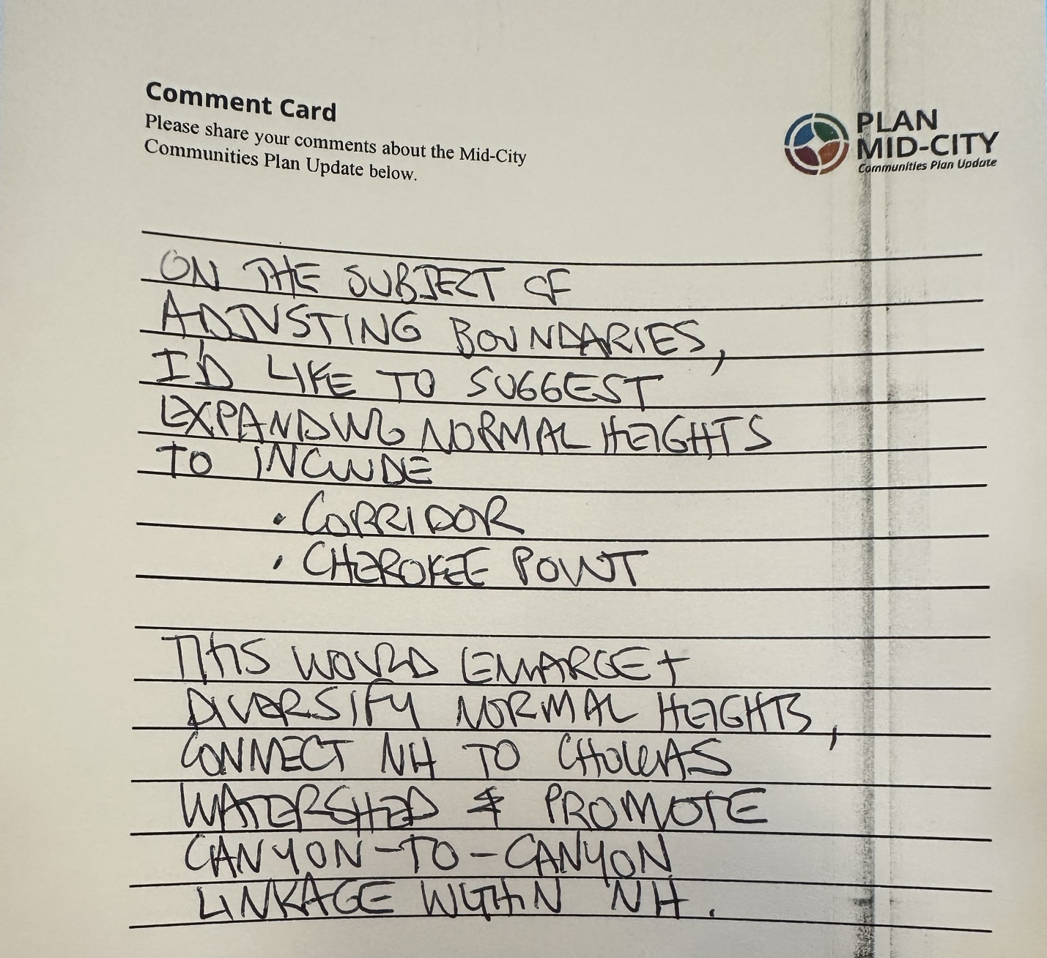

APPENDIX E – IN- PERSON SIGN IN SHEETS AND ZOOM ATTENDANCE
IN-PERSON SIGN-IN SHEETS
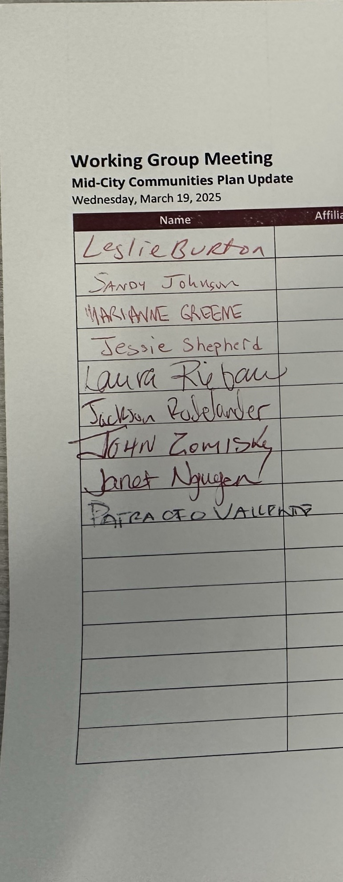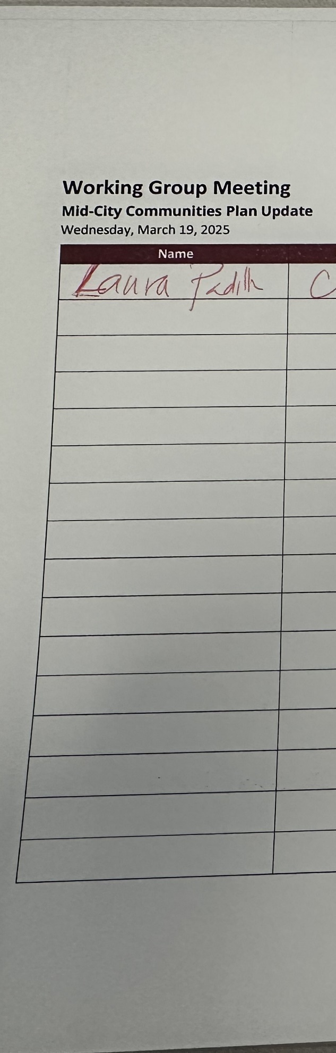

ZOOM LIST OF PUBLIC ATTENDEES
Annie R
Audrey Gallagher
Dominique Salazar
Edwin Lohr
Jay Corrales
Len Angle
Matt Gelbman
Mauro Soria
Melissa Elder
Michael Karns
Natalia Hernandez
Nicole Bartone
Patty Vaccariello
Paul Jamason
Priscilla Ann Berge
Ramie Zomisky
Renee Mezo
Rosario Martinez
Iannacone
Sarah Axford
Susan Baldwin
Tess Luoma

