CONSTRUCTION NOTICE:
Morena Blvd. and Milton St. Intersection Closed for Two Weeks

Construction on the Morena Conveyance South & Middle and Conveyance Bike Lanes Project is scheduled to begin in the intersection of Morena Blvd. and Milton St. on Friday, Dec. 5. Work is expected to continue Monday through Friday, 7 a.m. to 4 p.m., for two weeks. Crews will install shoring beams in preparation for pipeline work scheduled to begin in early 2026. At that time, crews will install two new pipelines that will connect to the previously constructed pipeline on Milton St., marking a major milestone for the Pure Water Program. Outlined below are the work plan and the expected impacts to your neighborhood. This work plan is designed to allow the contractor to progress as quickly and safely as possible through the area.

Please be advised that intersection of Morena Blvd. and Milton St. will be closed 24 hours a day, Monday through Friday, for two weeks. The intersection will reopen on weekends. A detour route will be in place. Please see the map below illustrating the traffic control plan that will be in place throughout the duration of this phase of work. For your safety, please follow all posted signage and plan extra time when traveling in the area to accommodate traffic delays.

During working hours, 7 a.m. to 4 p.m., Monday through Friday, crews will operate large
excavators to dig the trench where the shoring beams will be installed. All the work will take place behind the barricades of the work zone to ensure the safety of the public and crews while working. While crews are working, typical noise associated with construction may be heard. Throughout this work, crews will maintain the cleanliness of the work zone to minimize any dust leaving.

Please be advised that rain and inclement weather may impact the project schedule. Thank you for your patience and understanding as we make progress on this important project.

Sign up for e-blasts:
Regular project updates will continue to be shared via email blast. We strongly recommend adding yourself to the subscriber list to stay informed on the project. Please scan the QR code to the right, enter your contact information, and select lists # 4 & # 5 for the Morena South and Morena Middle Pipelines.

Please contact purewatersd@sandiego.gov or 833-MOR-PWSD (833-667-7973) with questions about the City’s Pure Water Program and the Morena Conveyance South & Middle and Conveyance Bike Lanes project, and a team member will get back to you within one business day.
The map below displays the traffic control setup on Genesee Avenue.
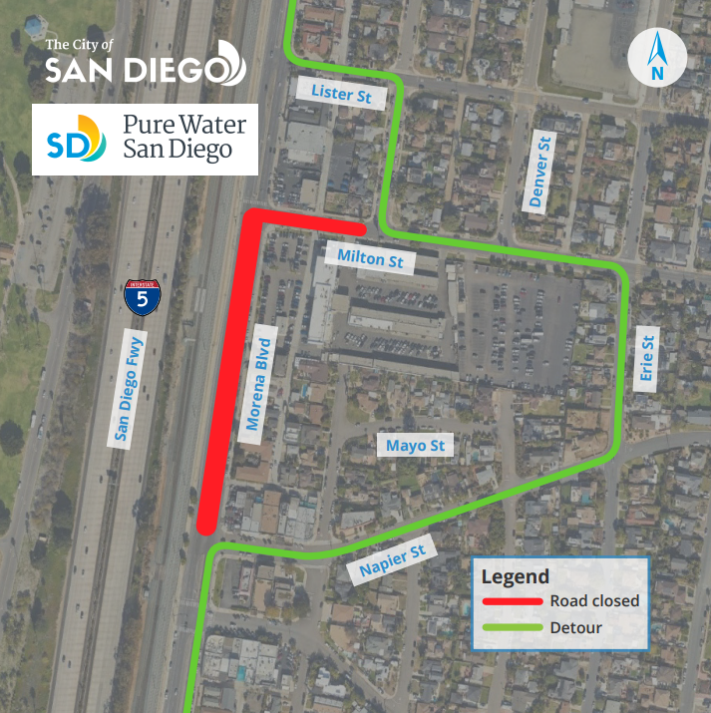
Why:
Pure Water San Diego is the City of San Diego's phased, multi-year program that will provide nearly half of San Diego's water supply locally by 2035 and significantly reduce treated discharges from the Point Loma Wastewater Treatment Plant. Pure Water San Diego will use proven water purification technology to clean recycled water to produce safe, high-quality drinking water. The program offers a cost-effective investment for San Diego's water and wastewater needs. San Diegans are getting dual value from this investment — reliable, sustainable drinking water and avoided wastewater costs. The Morena Conveyance South & Middle and Conveyance Bike Lanes project is one of several major projects in Phase 1 of Pure Water San Diego.

