
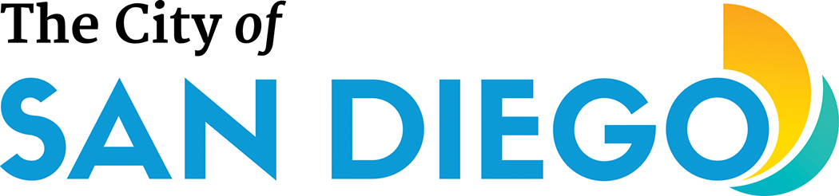
Recycled Water
System Notification

Dear Customers,
We apologize for the inconvenience and appreciate your patience. There are several emergency projects underway, and the Public Utilities Department is unable to deliver recycled water to the 640 and 790 Pressure Zones. See attached map for the limits of the 640 and 790 pressure Zones. We will send an update once the emergency has been repaired. The Public Utilities Department is committed to working closely with our customers to minimize any disruption. We are making every effort to reduce the impact on the recycled water supply.
In the meantime, we request your assistance by minimizing irrigation. For those with a Dual Plumb and Cooling Tower system, it is recommended to switch over to potable water.
For more information, please call Hudson McLintock (619) 527-7680. Additional information on the Recycled Water Program and other important water infrastructure projects is available online at www.sandiego.gov/water.

