

**CITY OF SAN DIEGO**

**TRANSPORTATION & STORM WATER DEPARTMENT**

**DISABILITY SERVICES DEPARTMENT**

**DEPARTMENT OF PUBLIC WORKS DEPARTMENT – E&CP**

**APPROVED MATERIALS LIST (AML) FOR**

**DETECTABLE WARNING TILES (DWT)**

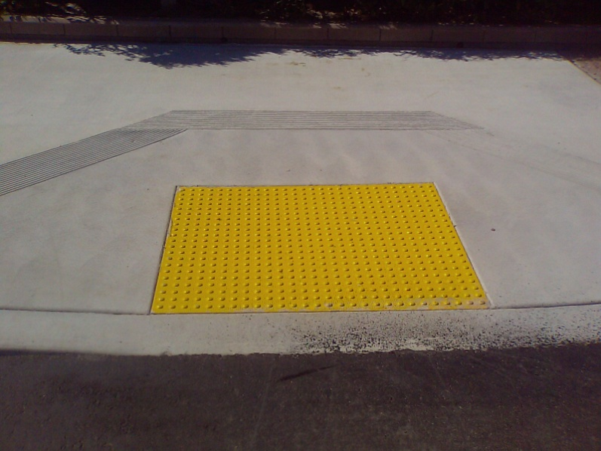



**November 2011**

**CITY OF SAN DIEGO**

**APPROVED MATERIALS LIST FOR DETECTABLE WARNING TILES (DWT)**

**Purpose:** The following list sets forth the City’s approved materials for Detectable Tactile Warning Tiles (DWT) on curb ramps and other areas that require detectable warning tiles installed within the City’s right-of-way.



|  |  |  |  |  |
| --- | --- | --- | --- | --- |
| **Type of Detectable Tactile Warning Tile** | **Specifications Reference** | **Manufacturer** | **Additional**  **Requirements** | **Manufacturer Literature** |
| Cast In Place Detectable Warning (Vitrified Polymer Composite) | Section 216, City of San Diego Supplement | Armor Tile Tactile Systems by Engineered Plastics Inc., 300 International Drive Suite 100  Williamsville, NY 14221 | SDG-130, City of San Diego Standard Drawings |  |
| Cast In Place Detectable Warning (Stainless Steel) | Section 216, City of San Diego Supplement | Advantage Tactile Systems by Advantage Tactile Systems 241 Main Street, Suite 100 Buffalo, NY 14203 | SDG-130, City of San Diego Standard Drawings |  |
| Cast In Place Detectable Warning (Reinforced Composite) | Section 216, City of San Diego Supplement | ADA Solutions by ADA Solutions P.O. Box 3 North Billerica, MA 01862 | SDG-130, City of San Diego Standard Drawings |  |
| Replaceable Wet Set (Reinforced Composite) | Section 216, City of San Diego Supplement | ADA Solutions by ADA Solutions P.O. Box 3 North Billerica, MA 01862 | SDG-130, City of San Diego Standard Drawings |  |
| Wet Set Replaceable Detectable Warning Panel (Polymer Concrete) | Section 216, City of San Diego Supplement | Armorcast Detectable Warning Panel  By Armorcast Products Company  13230 Saticoy Street  North Hollywood, Ca 91605 | SDG-130, City of San Diego Standard Drawings |  |
| Access Tile Cast in Place Replaceable (Composite) | Section 216, City of San Diego Supplement | Access Tile Tactile Systems,  241 Main Street, Suite 100, Buffalo, New York, 14203 | SDG-130, City of San Diego Standard Drawings |  |
| Metapanel (Stainless Steel) | Section 216, City of San Diego Supplement | Metadome, LLC  P.O. Box 7534  Madison, WI 53707 | SDG-130, City of San Diego Standard Drawings |  |

**Limitations:** Products specified here are strictly limited to specific types and models submitted, and tested by the City of San Diego. Other products not included in this AML and offered by the same manufacturers listed will not be accepted. Refer to manufacturer’s technical specifications and physical properties in effect at the time of approval for complete requirements.

**Procedures for Product Review Submittal:** Applicants requesting other detectable warning tile products be included in the City’s AML must comply with the following submittal, review and approval process.

1. To submit products for review, first contact the Public Works Department Curb Ramp Committee Chair. Do not submit materials or request without contacting the Committee Chair.

Edric Doringo, Curb Ramp Committee Chair

City of San Diego

Public Works Department – Engineering & Capital Projects

Right of Way Design Division

600 B Street, Suite 800

San Diego, CA 9210

[EDoringo@sandiego.gov](mailto:EDoringo@sandiego.gov)

2. DWT shall comply with the latest editions of the City of San Diego Standard Drawing for Detectable Warning Tile and the City of San Diego Supplement, Subsections 216 and 303.

3. DWT submittals shall be in 3 copies and shall contain manufacturer’s product data for each specified product, including:

1. Installer’s Certification
2. Installation Instructions
3. Cleaning and Protection Specification
4. Maintenance Recommendations
5. 2 tile samples, 18” x 18” minimum size of the kind proposed for use
6. Name and contact information of the manufacturer of the Detectable Warning Tile.
7. Name and contact information of the local supplier and vendor of the Detectable Warning Tile.
8. One copy of the completed test report(s) from qualified independent testing laboratories to certify that materials proposed for use are in compliance with requirements of and meet or exceed the properties indicated in the City of San Diego Supplement Section 216, “Detectable Warning Tiles” and manufacturer’s published physical properties.  All test reports shall be current within a 24-month period. The test report(s) must bear the name of the manufacturer, the product name and number and date of test.

4. There is no guaranteed time frame for completion of product review as much of the information on criteria such as long term testing, service, and durability may not be readily available.

5. Field Test: It is required that one local installation of the product being submitted for review be in place for at least a year. This installation must be in a high traffic location to be determined or approved by the Curb Ramp Committee (committee). A remote installation may be reviewed at the discretion of the committee.

6. If the product passes the review and field test, only then it will then be added to the AML.

7. Once a product is listed in the AML and prior to use, the Engineer may request quality control testing information from the manufacturer and samples to be tested by the City for quality assurance in accordance with subsection 4-1 of the standard specifications.  Any product failing to meet the minimum specified physical property values will be removed from the AML.  Changes in the original submitted information e.g., place of manufacture, company ownership, material formulation, or physical dimensions will be the cause for the removal of the product from the AML.  Removal from the AML will stay in effect until the AML committee is satisfied all AML listing requirements are met.

8. Product warranties shall be kept and maintained by the City’s Street Division of the City’s Transportation & Storm Water Department.

**References:**

1. City of San Diego Standard Drawings:

<http://www.sandiego.gov/engineering-cip/pdf/stddraw06/StdDraw06.pdf>

1. City of San Diego Supplement:

<http://www.sandiego.gov/engineering-cip/pdf/citysup06.pdf>.

Should you have any questions or need additional information on this list, please contact:

Edric Doringo, Curb Ramp Committee Chair

City of San Diego

Public Works Department – Engineering & Capital Projects

Right of Way Design Division

600 B Street, Suite 800

San Diego, CA 92101

[EDoringo@sandiego.gov](mailto:EDoringo@sandiego.gov)