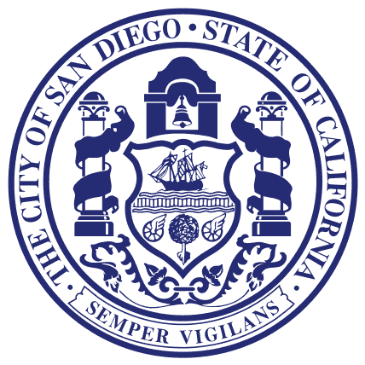
Councilmember Lorie Zapf
Council District TWO

For Immediate Release May 13, 2016
Media Questions Contact: Donna Cleary 619-236-6622

Councilmember Lorie Zapf Urges Book Donations to
City of San Diego Book Drive

PSA ON BOOK DRIVE

https://youtu.be/g4-hetSKluI

Several weeks ago, Councilmember Lorie Zapf in collaboration with the San Diego Library Department, kicked off a City of San Diego Children’s Book Drive will all of her Council Colleagues joining in on this effort.

“The response has been overwhelming,” said Zapf. “The Pacific Beach Taylor Library has already filled three bins with new and gently used books,” she added. Additionally, the Ocean Beach Library has filled their bin as well.

The book drive ends on May 31st and next week will be the halfway point for book collections.
The collected books will be turned over to the Library Department where they will be distributed to children to encourage summer reading and prevent the summer literacy slide.

Please drop off books to any of locations listed below:

San Diego Central Library
City Administration Building
City Operations Building

District 1:
Carmel Valley Library
La Jolla/Riford Library
University Community Library

District 2:
Clairemont Library
Ocean Beach Branch Library
Point Loma Hervey Library
Pacific Beach Taylor Library

District 3:
North Park Library
University Heights Library

District 4:
Oak Park Library
Paradise Hills Library
Valencia Park/ Malcolm X Library

District 5:
Rancho Bernardo Library
Scripps Miramar Ranch Library

District 6:
Mira Mesa Library
North Clairemont Library

District 7:
Allied Gardens/Benjamin Library
Serra Mesa- Kearny Mesa Library
Tierrasanta Library

District 8:
Logan Heights Library
Otay Mesa- Nestor Library

District 9:
College- Rolando Library
Kensington- Normal Heights Library

