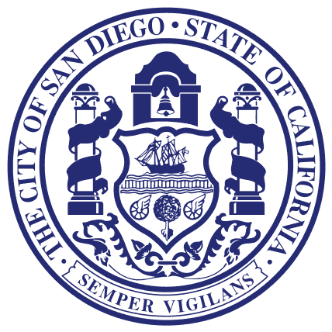
Councilmember Lorie Zapf
Council District TWO

For Immediate Release June 13, 2016
Media Questions Contact: Donna Cleary 619-236-6622

Zapf Successful in Swatting Out Flies in Mission Beach
Council Supports in the Name of “Public Health”

June 13, 2016: Today, the San Diego City Council voted on the final version of the City of San Diego Budget. As part of the budget, Councilmember Zapf asked for an additional trash pickup in the Mission Beach area to prevent summer fly infestation. The Independent Budget Analyst added support for this modification since it is viewed as a public health and safety issue.
“We have small businesses and restaurants who count on visitors and tourists to dine, however, there is such a large concentration of flies in Mission Beach these restaurants are getting cited for excessive flies by County Health officials. Additionally, tourists have been complaining online with negative reviews, which hurts their business and in turn hurts the TOT bottom line,” said Councilmember Zapf.
“Over the last two years, I have had an opportunity to learn more about the lifecycle of the fly then I ever thought I could learn,” said Zapf. “The second trash pick-up is necessary and will help cut the fly cycle to prevent further breeding and reduce the amount of flies in Mission Beach,” added Zapf.
Although, funding for this year is approved in the budget allocation. It is important to provide a continuous funding source. Councilmember Zapf has encouraged the residents of Mission Beach to create a Mission Beach Community Benefits District to guarantee funding for the second trash pick-up in future years.
###

