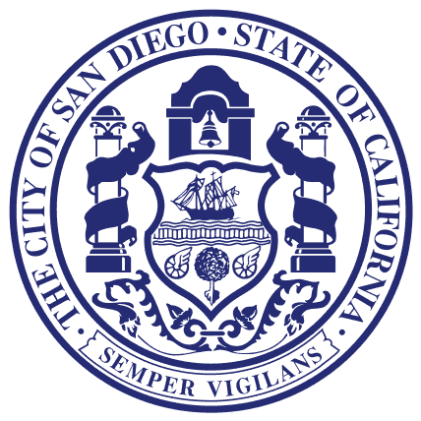
Councilmember Lorie Zapf
Council District TWO

For Immediate Release March 15, 2016
Media Questions Contact: Donna Cleary 619-236-6622

Councilmember Lorie Zapf honors Ralph Rubio

In an action sponsored by Councilmember Lorie Zapf, the San Diego City Council proclaimed April 5th, 2016 as “Ralph Rubio Day” in the City of San Diego. “Ralph Rubio is a true San Diegan, who has achieved great business success and is committed to the preservation of our local beaches,” said Councilmember Lorie Zapf.

Since 1983, Rubio’s has grown to nearly 200 restaurants throughout California, Arizona, Colorado, Utah and Nevada having sold more than 200 million original fish tacos.

In 1983, Rubio and his father opened the first Rubio’s restaurant on Mission Bay Drive in Pacific Beach. Rubio brought his love of fish tacos to San Diego after first discovering them during a college trip to San Felipe while attending San Diego State University.

Rubio developed a passion for protecting the ocean and giving back to the local San Diego communities with the Rubio’s Coastal Grill’s annual CoastFest, one of the largest organized beach cleanups in San Diego.

Today, Rubio serves as "head of culinary," where he oversees menu development and is heavily involved with marketing and restaurant design.

Rubio is a 1978 graduate of San Diego State University as well as a former member of the Campanile Foundation.

