Councilmember Lorie Zapf
Council District TWO

For Immediate Release April 25, 2016
Media Questions Contact: Donna Cleary 619-236-6622

Councilmember Lorie Zapf honors Council District 2 Volunteers

On Saturday, April 23, 2016, Councilmember Lorie Zapf honored nearly 100 non-profit, civic, education and community volunteers in San Diego City Council District 2. Several hundred attended the breakfast sponsored by Shades Oceanfront Bistro and Wonderland Ocean Pub in Ocean Beach, The Olive Café and Bakery in Mission Beach, SDG&E, Cox Cable, Starbucks and Belmont Park.

The event was held during National Volunteer Appreciation Month and honored a wide cross- section of volunteers in Councilmember Zapf’s district. “Honoring those who volunteer their time to make our schools, communities and city a better place to live is my privilege,” said Zapf. “Selfless service for the good of your community is an extraordinary gift,” she added.

Each volunteer was recognized and received a City of San Diego certificate of recognition. Additionally, Councilmember Zapf presented a special award posthumously to honor Maruta Gardner as the Volunteer of the Year in Council District 2. “We have dedicated this first award to her memory and in the following years it will be awarded to a volunteer with the same selfless passion,” said Zapf. Gardner was a very distinguished, retired educator and was also known as the “Graffiti Eradicator” of Mission Beach. For nearly 25 years, she made her community a better place to live. Sadly, Gardner was hit by an impaired driver while she was painting out graffiti on February 11th in Mission Beach. Gardner’s husband, Willie Gardner accepted the award to a standing ovation.
Organizations were asked to nominate outstanding volunteers from their non-profits, schools, community, faith based and youth programs who make a difference. Below is a breakdown of those volunteers who were recognized:

Pacific and Mission Beach Honorees
Sara | Berns | Discover PB
Ellen | Citrano | Pacific Beach Town Council
Brian | Curry | Pacific Beach Planning Group
Fred | Day | Mission Beach Town Council
Karl | Jaedtke | Pacific Beach Community Foundation
Catherine | Jolley | Pacific Beach Town Council
Jill | Lester | Mission Beach Town Council
Dennis | Lynch | Mission Beach Precise Planning Group
Klaus | Mendenhall | Mission Beach Town Council
Mike | Meyer | Mission Beach Precise Planning Group
Abby | Murrey | Mission Beach Town Council
Chris | Olson | PB/MB Community Collaborators
Micaela | Porte | Pacific Beach Town Council
Mary | Saska | Mission Beach Planning Group
Will | Schussel | Mission Beach Precise Planning Group
Marcella | Teran | PB/MB Community Collaborators
Jo | Unger | Mission Beach Town Council
Debbie | Watkins | Mission Beach Precise Planning Group
Gary | Wonacott | Mission Beach Town Council
Mary Lou | Benzel | Pacific Beach Women's Club
Sarah | Mattinson | Mission Beach Women's Club
Devon | Muto | Beautiful PB
Gary | Reilly | Beautiful Mission Beach
Jody | Ross | Pacific Beach Women's Club
Jack | Bloom | Pacific Beach Middle School
Lynn | Edmunds | Pacific Beach Middle School
Jennifer | Tandy | Friends of Pacific Beach Secondary Schools
Jennifer | Upton | Crown Point Junior Music
Keith | Keillor | San Diego Canoe Kayak Team
MD | Margo | Cortez Racing Association
James | Rojas | Kai Elua Outrigger Canoe Club
Julian | Cadena | Crown Point Junior Music

Ocean Beach and Point Loma Honorees
John | Ambert | Ocean Beach Planning Board
Michele | Amsterdam | Ocean Beach Mainstreet Association
Blake | Herrschaft | Ocean Beach Planning Board
Robert Tripp | Jackson | Point Loma Association
Julie | Klein | Ocean Beach Mainstreet Association
Melanie | Nickel | Midway Planning Group
Tom | Perrotti | Ocean Beach Community Development Corp.
Pete | Ruscitti | Ocean Beach Planning Board
Ed | Lynds | Point Loma Community Church
Barry | Whitfield | Rock Church
Michael | Ambagtsheer | Warren Walker School
Karen | Anderson-Thatcher | Warren Walker School
Paul | Arenson | Cabrillo Elementary School
Lisa | Hill | Kids First at Sunset View Elementary
Tyler | McCort | Cabrillo Elementary School
Dominique | Mimno | Loma Portal Elementary
Warren | Tam | Cabrillo National Monument
Will | Hage | Peninsula YMCA

Clairemont Honorees
Rod | Pendon | Clairemont Library
Lynn | Titialii | Clairemont Community Planning Group
Scott | Wentworth | Clairemont Planning Group
Kyley | Christy | Clairemont Town Council Garden Tour Committee
Dolores | Juditz | Clairemont Woman's Club
Lynn | Little | Clairemont Town Council Garden Tour Committee
Carrie | Munson | Clairemont Town Council Garden Tour Committee
Eden | Yaege | Clairemont Town Council Garden Tour Committee
Stacey | Beckerly | Toler Elementary PTA
Pauline | Burt | Bay Park Elementary Foundation
Carma | Sanchez | Longfellow Spanish Immersion School
M. Eloise | Battle | Tecolote Canyon Citizens Advisory Committee
Ingrid | Lewin | Tecolote Canyon Citizens Advisory Committee
Margot & Walter | Linback | Tecolote Canyon Nature Center
Sherlie | Miller | Friends of Tecolote Canyon
Shannon | Harris | Thrive Public Schools
David | Vavasevr | St. Charles Borromeo Academy

Linda Vista Honorees
Margarita | Castro | Linda Vista Planning Group
Dorothy | Greenan | Linda Vista Town Council
Dr. G. Tom | Kaye | Linda Vista Town Council
Dottie | Perez | Linda Vista Planning Group
Tisha | Rocha | Linda Vista Planning Group
Kimberly | Weber | Linda Vista Planning Group
Katie | Coutermarsh | University of San Diego

District Wide Honorees
Dani | Ramos | The Rescued Dog
Bill | Whiteside | San Diego Audubon Society
Ken | Stipanov | NTC Foundation
Bilal | Edward Rivers | Muslim Community Services of San Diego
Steve | Mitchell | American Culture Council
Barbara | Calantas | Ocean Discovery Institute
Joel | Kalmonson | San Diego River Park Foundation
Gabriella | Mark | Plant with Purpose
Gina | Adams | Masonry Industry Training Association
T.J. & Warren | Cox | Just Call Us Volunteers
Cassie | Edmonds | San Diego Foundation
Michele | Fallon | Hearts for San Diego
Lara | Haine | San Diego Writers Ink
Darren | Hamrick | Hearts for San Diego
Michelle | Honig | Just Call Us Volunteers
Syd | Marshal | Hearts for San Diego
Elizabeth | Curtis | San Diego Family Justice Center
Kevin | Kenny | San Diego Dental Health Foundation
Meribeth | Russell | Freedom Dogs
Gregg | Stoner | West Coast Drill Instructor Association
Marsha | Harris | Carly's Cause
Dayna | Hoff | Autism Tree Project Foundation
Lia | Idrus | San Diego Youth Services
Karen | Malin | Words Alive
Judy | Yates | Reading Legacies

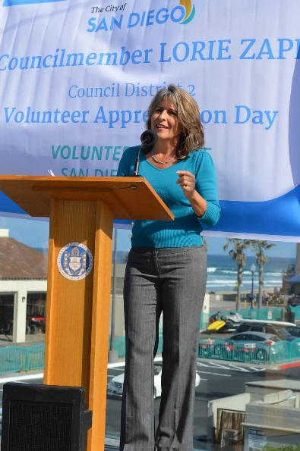
Councilmember Lorie Zapf kicking-off Volunteer Appreciation Day.

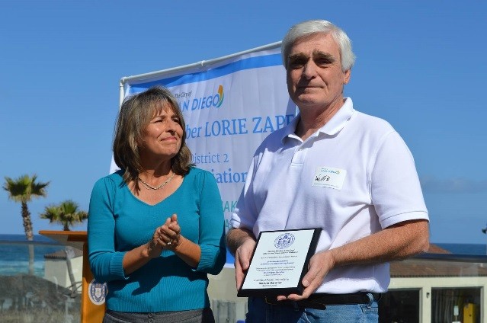
Willie Gardner accepting Maruta Gardner’s award posthumously.
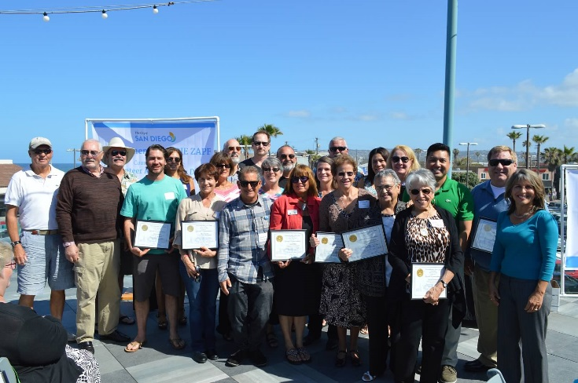
Community Leader Honorees
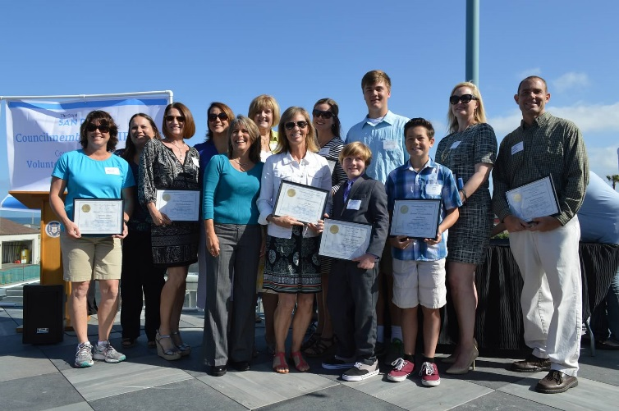
Education Honorees
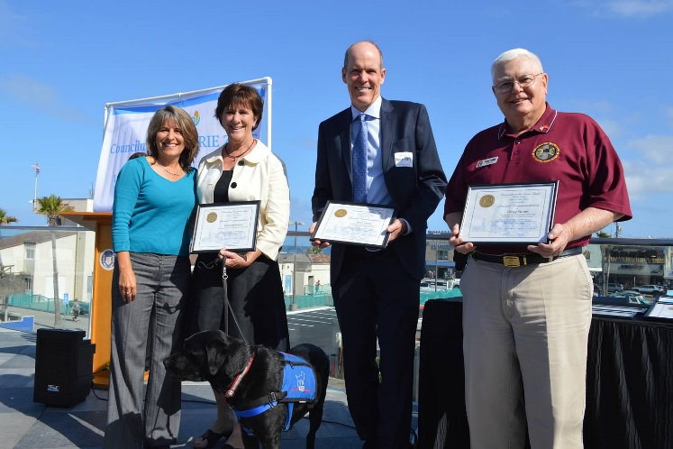
Veterans Group Honorees
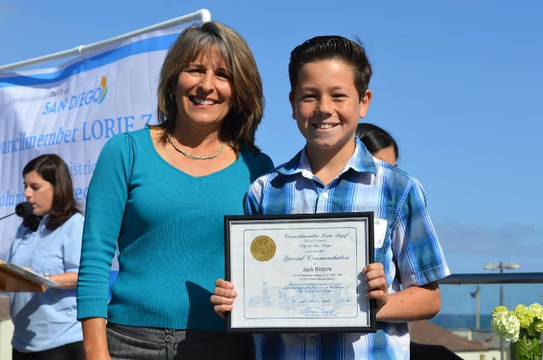
Pacific Beach Middle School Student, Jack Bloom, receiving award

